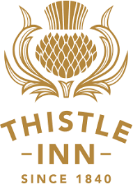
Mid-Winter Christmas menu
Main + Dessert $39

Main
Roast Chicken, potato, beans, cranberry jus
Wild mushroom risotto, truffle oil
Lamb rump, creamed barley, mint pesto, jus

Dessert
Sticky Date pudding, vanilla bean icecream
Pear, ginger, chilli, lemongrass & pistachio crumble, honey gelato

